**Subject: Intelligent Systems Laboratory (DJS23DLPC503)**

**AY: 2025-26**

**Experiment 1**

**(Problem Solving)**

**Name : Soham Walam Roll No : D102 SAP ID : 6009230094**

**Aim:** Implement domain specific functions for given problems required for problem solving.

**Theory:**

There are two domain specific functions required in all problem-solving methods.

1. GoalTest Function:



2. MoveGen function:



**Lab Assignment to do:**

Create MoveGen and GoalTest Functions for the given problems

1. **Water Jug Problem**

There are two jugs available of different volumes such as a 3 litres and a 7 litres and you have to measure a different volume such as 6 litre.

**MoveGen:**

def water_jug_movegen(state, capacities=(3, 7)):

x, y = state

moves = []

moves.append((capacities[0], y))

moves.append((x, capacities[1]))

moves.append((0, y))

moves.append((x, 0))

pour = min(x, capacities[1] - y)

moves.append((x - pour, y + pour))

pour = min(y, capacities[0] - x)

moves.append((x + pour, y - pour))

return set(moves)

**GoalTest:**

def water_jug_goaltest(state, goal=6):

return goal in state

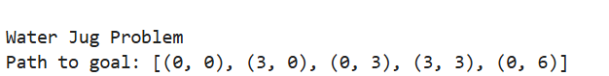

2. **Travelling Salesman Problem**

A salesman is travelling and selling his/her product to in different cities. The condition is that it has to travel each city just once.

**MoveGen**:

def tsp_movegen(cities):

return list(itertools.permutations(cities))

**GoalTest**:

def tsp_goaltest(path, start_city):

return path[0] == start_city and path[-1] == start_city and len(path) == len(set(path))

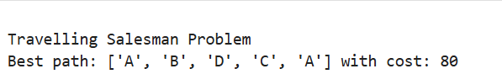

3**. 8 Puzzle Problem**

An initial state is given in an 8 puzzles where one place is blank out of 9 places. You can shift this blank space and get a different state to reach to a given goal state.

**MoveGen**:

def puzzle_movegen(state):

moves = []

size = 3

zero_index = state.index(0)

row, col = divmod(zero_index, size)

directions = {

"up": (row - 1, col),

"down": (row + 1, col),

"left": (row, col - 1),

"right": (row, col + 1),

}

for (r, c) in directions.values():

if 0 <= r < size and 0 <= c < size:

new_index = r * size + c

new_state = list(state)

new_state[zero_index], new_state[new_index] = new_state[new_index], new_state[zero_index]

moves.append(tuple(new_state))

return moves

**GoalTest**:

def puzzle_goaltest(state, goal=(1,2,3,4,5,6,7,8,0)):

return state == goal

